Probability Unit Plan
Grades 3-6
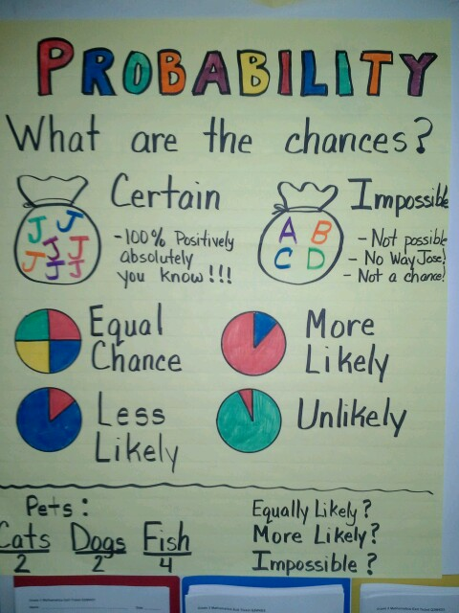
Kristine Gustafson
St. Mary’s Mission School - Red Lake, MN
keg.8993@gmail.com
Laura Dahl
Clearbrook-Gonvick School
ldahl@clearbrook-gonvick.k12.mn.us

Kathy McKeown
Lincoln Elementary School - Bemidji, MN
kathy_mckeown@isd31.net

Executive Summary
Students will work with a variety of manipulatives and in numerous situations to practice, explore, and understand many different examples of probability. Students will have the opportunity to learn useful real world and problem solving strategies.
The lessons are designed to be used during a normal math period or as supplemental problem solving activities throughout the school day.

Minnesota Standards Addressed:

3.4.1.1
Collect, display and interpret data using frequency tables, bar graphs, picture graphs and number line plots having a variety of scales. Use appropriate titles, labels and units.

4.4.1.1
Use tables, bar graphs, timelines and Venn diagrams to display data sets. The data may include fractions or decimals. Understand that spreadsheet tables and graphs can be used to display data.

6.4.1.1
Determine the sample space (set of possible outcomes) for given experiment and determine which members of the sample space are related to certain events. Sample space may be determined by the use of tree diagrams, tables or pictorial representations.

6.4.1.2
Determine the probability of an event using the ratio between the size of the event and the size of the sample space; represent probabilities as percents, fractions and decimals between 0 and 1 inclusive. Understand that probabilities measure likelihood.

6.4.1.4
Calculate experimental probabilities from experiments;

MCA Sampler Items:
This example question is the only Data Analysis and Probability question presented on the MCA-III item sampler test for 4th grade mathematics.
http://minnesota.pearsonaccessnext.com/item-samplers/math/

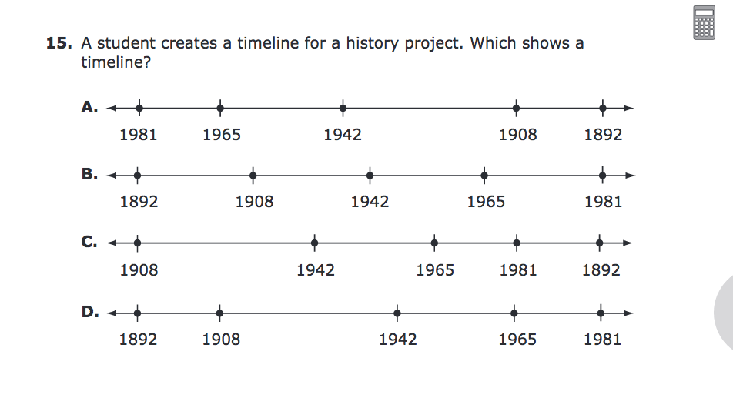

Table of Contents
Topic | Title | Page
Pre-Assessment | Pre-Assessment | 5-6
Lesson 1 | Shorts and Shirts | 7-9
Lesson 2 | Ice Cream Cones | 10-13
Lesson 3 | Possible Outcomes | 14-15
Lesson 4 | Coin Toss | 16-17
Lesson 5 | Bean Boozled | 18-19
Lesson 6 | One Number Cube | 20
Lesson 7 | The Hare & the Tortoise Game | 21-22
Lesson 8 | Dice Game | 22-25
Lesson 9 | Card Game | 26
Lesson 10 | Flipping Coins | 27-30
Lesson 11 | Pirate’s Treasure (The Maze) | 31-34
Lesson 12 | The World at Your Fingertips | 35-40
Lesson 13 | Mystery Spinners (The Big Wheel) | 41-44
Lesson 14 | Scoring Option Game | 45-50
Lesson 15 | Parachute Jump Competition | 51-58
End-of-Unit Assessment | End-of-Unit Assessment | 59-60
Pre-Assessment
Name:_______________ Date:__________

1.
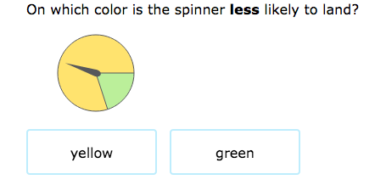
2.
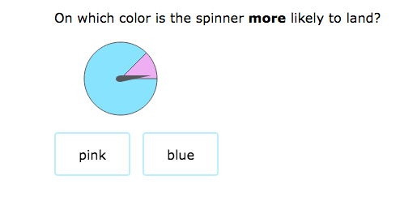

3. If you roll a 6 sided number cube, what is the probability of rolling an even number? Write your answer as a fraction.

4. If you roll a 6 sided number cube, what is probability of rolling a one? Write your answer as a fraction.

5.
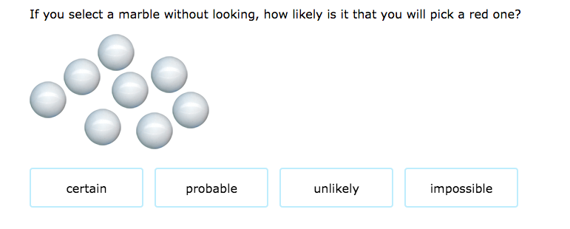

6.
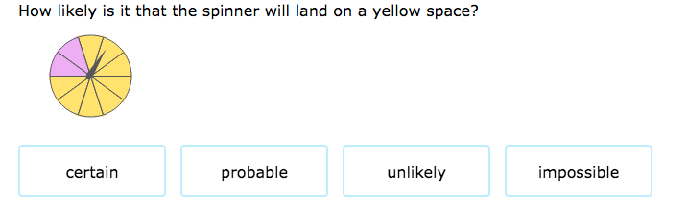

7. The weather forecast stated that the chance of rain is 40%. According to the forecast, is it more likely to rain or not rain?

8. If a number cube is rolled once what is the probability of rolling a 7?

Lesson 1
Shorts and Shirts
This activity can be found on the illuminations website.
http://illuminations.nctm.org/Lesson.aspx?id=781

Minnesota Mathematics Standard:
6.4.1.1
Determine the sample space (set of possible outcomes) for given experiment and determine which members of the sample space are related to certain events. Sample space may be determined by the use of tree diagrams, tables or pictorial representations.
Learning Target: I can determine all the possible outcomes for shorts and shirts using pictorial representations, table or tree diagram.
Material:
Colored crayons (red, green, yellow, blue, orange, brown, black, and purple)
Shorts and Shirts Activity Sheet
Launch:
Distribute the Shorts and Shirts activity sheet to each student. Students will be coloring outfits to determine the total number of combinations possible. Make sure that each student has eight crayons: red, green, yellow, blue, orange, brown, black, and purple
Explore:
Students are to find the combinations that are possible with shirts and shorts, using the shorts and shirts activity sheet. Each shirt must be a solid color, either yellow, orange, blue or red. Each pair of shorts must be a solid color, either brown, black, green, or purple. How many different outfits can be made? No two outfits should be the same. Guide students to predict how many different outfits can be colored. They should record their predictions on the activity sheet. Allow enough time for students to color their combinations on the activity sheet. Place students in pairs to compare their results.
Share:
As a class, discuss the results. Students should have the following 16 correct combinations:
Yellow shirt, Brown shorts Orange shirt, Brown shorts
Yellow shirt, Black shorts Orange shirt, Black shorts
Yellow shirt, Green shorts Orange shirt, Green shorts
Yellow shirt, Purple shorts Orange shirt, Purple shorts
Blue shirt, Brown shorts Red shirt, Brown shorts
Blue shirt, Black shorts Red shirt, Black shorts
Blue shirt, Green shorts Red shirt, Green shorts
Blue shirt, Purple shorts Red shirt, Purple shorts
Ask students to compare their predictions to the correct total number of combinations. Students who made the correct predictions could share their reasoning with the class.
In addition to the organized list shown above, students may also make a table or a tree diagram to solve this problem.
Ask students to think about a general rule or pattern for determining the total number of combinations. Students should see that they could have multiplied the number of shirts possible (4) by the total number of shorts possible (4) to get a correct total number of 16 combinations.
Summarize:
Students will be estimating the number of possibilities that can be made from a given number of factors. They will compute the number of possibilities. Students will generalize the number of possible combinations that can be made.
Extension:
What if six colors are used for shirts?
(Solution: There would be twenty-four outfits.)
What if eight colors are used for shorts and eight for shirts?
(Solution: Sixty-four outfits could be colored.)

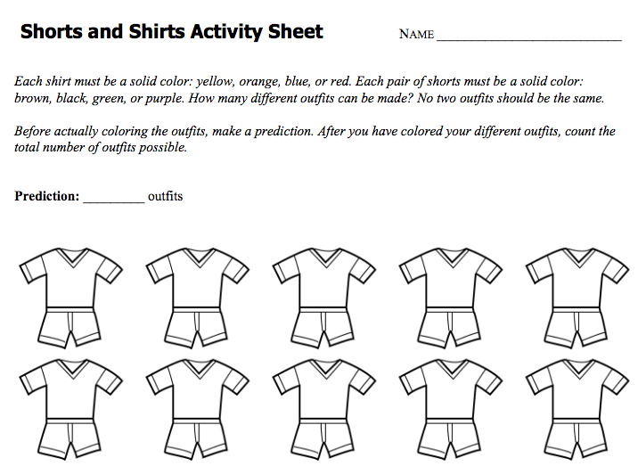
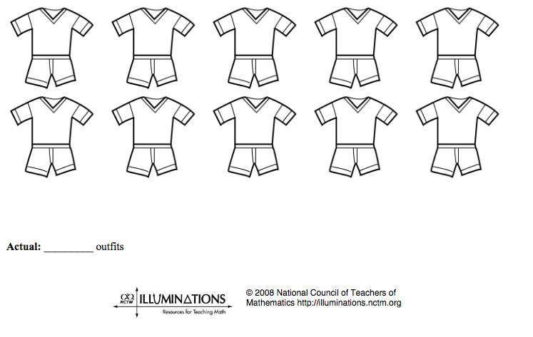
Lesson 2
Ice Cream Cones

This activity can be found on the illuminations website.
http://illuminations.nctm.org/lesson.aspx?id=785

Minnesota Mathematics Standard:
6.4.1.1
Determine the sample space (set of possible outcomes) for given experiment and determine which members of the sample space are related to certain events. Sample space may be determined by the use of tree diagrams, tables or pictorial representations.
Learning Targets:
1. I can predict the number of two-color combinations that can be made from eight colors.
2. I can determine the number of combinations that can be made.
3. I can generalize the number of possible combinations that can be made.
4. I can determine whether or not order matters mathematically.
Materials:
Ice Cream Cones Activity Sheet
Each student will also need the following colors of crayons: brown (chocolate), white (vanilla), red (strawberry), orange (orange sherbet), green (lime), yellow (lemon), purple (grape), and black (chocolate chips.)
Launch:
Distribute the Ice-Cream Cones activity sheet to each student. Students will be coloring ice cream cones to determine the total number of combinations possible.
Before starting the activity, read the scenario on the activity sheet. Individually, students should predict the number of different two-topping ice cream cones that are possible.
Explore:
Students should work individually to color and count their ice cream cones. In groups of two or three, discuss the results: both the types of ice cream cones created and the number.
Share:
Two issues should arise in group discussions:
1. Does order matter on the ice cream cone? For example, is an ice cream cone with vanilla on top and lime on the bottom different from one with lime on top and vanilla on the bottom?
2. Can the same flavor be used for both scoops?
As students discuss these questions in their groups, you may choose to let students decide on their own how to proceed. This will, of course, lead to different answers. Another option is to let students discuss these issues and make a class decision before proceeding; that way, all students are attempting to solve the same problem.
Extension:
Students are encouraged to discover all the combinations for a given situation. They use problem-solving skills (including elimination and collection of organized data) to draw their conclusions. Students also discuss whether or not order matters mathematically for the given problem. The use of higher-level thinking skills (synthesis, analysis, and evaluations) is the overall goal.
Depending on the assumptions that students make regarding order and repetition, the answers will vary:
If Order Matters:
Flavor may not be repeated: The first scoop can be any of the eight flavors, and the second scoop can be any of the seven flavors not yet used. Therefore, 8 x 7 = 56 possible combinations.
If Order Does Not Matter:
Flavor may not be repeated: This case is best solved by making an organized list, tree diagram, or table. On the Illuminations website page for this lesson, a great example of an organized list is shown. Flavor may be repeated: In addition to the 28 combinations possible when repeats are not allowed (as in the description above), there are eight additional possibilities, one for each case when both scoops the scoops are the same flavor. The result is 28 + 8= 36 combinations.
If the class did not come to consensus prior to completing the activity sheet, then a rich discussion can occur. Ask students who found 28 ice cream cones to share with other members of the class the reasoning behind their answer. [8 x 7 ÷ 2 = 28.] Though students may find four different answers to the original question, be sure to point out that none of the answers are wrong. It is important that students think about why their answers may be different, and you should push them to articulate why they got a different answer than another student.

Students who arrived at 56 combinations should also be allowed to share their reasoning, namely that order matters, but the same flavor cannot be used for both scoops. [8 x 7 = 56] Ask them to state why they consider vanilla-lime to be different from lime-vanilla.
Students who found either 36 or 64 combinations allowed for repetition of flavors, which is also a reasonable assumption.
Though students may find four different answers to the original question, be sure to point out that none of the answers are wrong. It is important that students think about why their answers may be different, and you should push them to articulate why they got a different answer than another student.
Additional question: "What if you allow either one or two scoops? How is the solution different?"
Summarize:
Students were to predict the number of outcomes of two-color combinations using up to 8 colors. However, this may be too many for younger students. I would perhaps start with three then four flavors/colors.

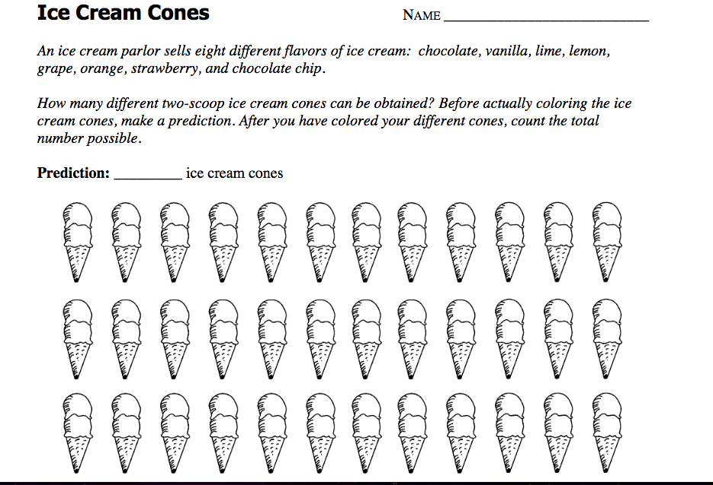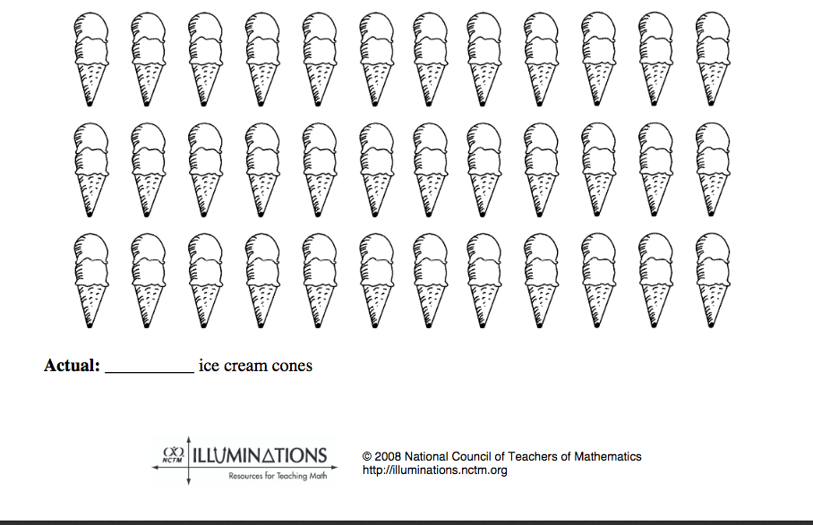

Lesson 3
Possible Outcomes
(certain, likely, unlikely, impossible)

Minnesota Mathematics Standard:
6.4.1.2
Determine the probability of an event using the ratio between the size of the event and the size of the sample space; represent probabilities as percents, fractions and decimals between 0 and 1 inclusive. Understand that probabilities measure likelihood.
Learning Targets:
I can determine if outcomes are likely, unlikely, certain, or impossible.
Materials:
Spinner
Index cards
Tape
Play dimes and pennies
Launch:
While having coins and spinners visible, introduce the ideas from the lesson to students. Use a spinner with the numbers 1,1,2,2,3,3,3, and 3 in each of 8 sections. Have students write the number they think the spinner will land on. Spin the spinner. Have volunteers who guessed correctly explain why they chose that number. Have volunteers who guessed incorrectly explain why they did not choose that number.
Explore:
Pose the following example: There are 6 yellow raisins and 1 brown left in the box. Laura is about to pick one. Is it likely, unlikely, certain, or impossible that she will pick a yellow raisin from the box? A brown raisin? Ask: Why can you not describe the probability of picking a brown raisin as likely in the example? Would you change your answer if there were only 4 yellow raisins? Discuss how you decide if picking an item of a certain color is impossible and certain.

Display four different rectangular shapes. Provide students with 4 cards with tape on the back. Label the cards: likely, unlikely, certain, and impossible. Ask: What is the chance of closing your eyes and pointing to a red space on each card?

 |  | SPACE
 | SPACE | SPACE
 | SPACE | SPACE
SPACE | SPACE | SPACE

Have volunteers come up, close their eyes, and point. Compare the results with the predicted outcome.
Have volunteers match the cards to the correct rectangles.
Then have students work in groups to fill bags with play dimes and pennies so that each bag matches the following probability: likely to pick a dime, unlikely to pick a die, impossible to pick a dime, or certain to pick a dime.
Share:
Discuss with students: How would you describe the probability of a coin landing on head? If you have 4 red cubes and 4 blue cubes, what 2 color cubes are you likely to pull out of a bag. Discuss with students what makes an event more or less likely to occur, impossible, certain, etc.
Summarize:
Students will be using the terms likely, unlikely, certain, or impossible according to outcomes from their activities in this lesson.
Extension
Have students match the words likely, unlikely, certain, or impossible with the words more, less, none, and all. Create some scenarios that will create conditions matching likely, unlikely, certain, or impossible.

Lesson 4
Coin Toss
Minnesota Mathematic Standards:
3.4.1.1
Collect, display and interpret data using frequency tables, bar graphs, picture graphs and number line plots having a variety of scales. Use appropriate titles, labels and units.
4.4.1.1
Use tables, bar graphs, timelines and Venn diagrams to display data sets. The data may include fractions or decimals. Understand that spreadsheet tables and graphs can be used to display data.
Learning Targets:
1. I can expressing outcomes from random experiments.
2. I can create a pictograph based on experiment results.
3. I can represent possible outcomes with tables/grids and draw conclusions from the results.
Material:
10 coins for each student
Paper
Pencils
Launch:
Review with students the concept of creating a bar graph. Also, discuss the probability concept of predicting possible outcomes based on a randomly conducted in an experiment.
Explore:
Discuss with students the basics regarding this activity. Do an example of 10 coin tosses together as a class—having 10 different students toss the coins. Tally the results as a pictograph. Then the students will now begin the activity. They will predict the results of flipping a coin 10 times (heads or tails) recording the predictions. Then they will each flip a coin 10 times and record the results.
Share:
The teacher should record the results on a master spreadsheet. Students will then predict the results of flipping the coin 20 times, recording predictions. They complete the activity by flipping the coin 20 more times and recording the results.
Summarize:
Teacher discusses with the class how the probability gets closer to 50% that a coin will land on either heads or tails as the amount of times the coin is tossed increases. This can be conveyed by explaining that since a coin only has two sides, each coin flip has an equal (50%) chance of landing on either heads or tails. If the coin flip is repeated many times, the distribution of outcomes forms a predictable pattern.

Lesson 5
Bean Boozled
Minnesota Mathematic Standard:
6.4.1.4
Calculate experimental probabilities from experiments

Learning Targets:
I can find possible outcomes from spinning a spin and tasting the good/bad flavored bean by doing an experiment.
Materials:
Bean Boozled spinner
Bean Boozled flavored jelly beans
Bean Boozled flavor recording sheet
Wastebasket or napkins
Paper/pencil
Launch:
Have you ever had a bad tasting jelly bean? Well, we are going to play a game called Bean Boozled where 2 beans look the same but one tastes good and the matching one tastes bad. It all depends on the spinning a wheel!
Explore:
Divide into groups based on the number of spinners you have. Spin the spinner and choose the corresponding color and record the flavor. Continue taking turns in your group until you have tasted at least 10 flavors. Since there are 20 spaces on the spinner the chance of getting a good bean is 10/20 and a bad bean is 10/20. If you figure the chances of getting a certain color it is 2/20. Show the math on the board.
Share:
Teacher should record on master spreadsheet all the flavors. Also, allow the students discuss the best and worst flavors.
Summarize:
Depending on the grade level and the number of trials you can find the theoretical probability of getting each flavor vs. experimental flavors chosen off the spinner OR you can just find the experimental good vs bad flavors since the theoretical probability would be 50/50 for each flavor chosen.

Bean Boozled
Coconut |  | Strawberry Banana  Smoothie
Spoiled Milk |  | Dead Fish
Buttered Popcorn |  | Berry Blue
Rotten Egg |  | Toothpaste
Peach |  | Chocolate Pudding
Barf |  | Canned Dog Food
Juicy Pear |  | Caramel Corn
Booger |  | Moldy Cheese
Tutti-Fruitti |  | Lime
Stinky Socks |  | Lawn Clippings

Bean Boozled
Coconut |  | Strawberry Banana  Smoothie
Spoiled Milk |  | Dead Fish
Buttered Popcorn |  | Berry Blue
Rotten Egg |  | Toothpaste
Peach |  | Chocolate Pudding
Barf |  | Canned Dog Food
Juicy Pear |  | Caramel Corn
Booger |  | Moldy Cheese
Tutti-Fruitti |  | Lime
Stinky Socks |  | Lawn Clippings

Lesson 6
Number Cube (Single)
Minnesota Mathematic Standards:
4.4.1.1
Use tables, bar graphs, timelines and Venn diagrams to display data sets. The data may include fractions or decimals. Understand that spreadsheet tables and graphs can be used to display data.
6.4.1.4
Calculate experimental probabilities from experiments;

Learning Targets:
I can find possible outcomes from rolling a number cube by doing an experiment.
Materials:
number cubes
paper/pencil
Launch:
Ever roll a number cube to decide who should start a game first? Which number do you choose? Is it your lucky number? Which number has the best chance of turning up the most times? In this experiment we will see which number you should choose next time you are deciding how to start a game.
Explore:
Work with a partner for this experiments. You and your partner will roll one number cube 36 times and tally the number of times each face of the number cube turns up. You will record the results on a table with 4 columns labeled Outcomes/Predictions/Tally/Total Frequency and 6 rows labeled 1,2,3,4,5,6. Before starting the experiment, predict the number of times each outcome will occur during the experiment. Write your predictions in the column labeled “Prediction.” Now begin rolling the number cube. Make a tally mark for each roll in the appropriate box in the “Tally” column.
Share:
When all groups have finished, report your results to the class. As a class, total the groups’ tallies for each outcome ,and write these totals in the boxes under the “Total frequency.” Make a bar graph using the data from your table.
Summarize:
What conclusion can you draw from the results? Which number came up more often? What does that tell you? Is it easier comparing the data from the bar graph or the table?

Lesson 7
The Hare & the Tortoise Game

Minnesota Mathematic Standards:
6.4.1.2 Determine the probability of an event using the ratio between the size of the event and the size of the sample space; represent probabilities as percents, fractions and decimals between 0 and 1 inclusive. Understand that probabilities measure likelihood.

Learning Targets:
I can see how experimenting with dice rolls can help me visualize the probabilities of rolling similar, or differing outcomes.

Materials:
Game direction and recording sheet
Colored chips or place holders
1 die per pair
Launch:
I’m going to roll this die 3 times and record whether the results are odd or even, This time we ended up with E, O, E. What other outcomes could we get? Record these on the board. This game is going to help you visualize what outcomes are the most likely to occur.
Explore:
Play the game: The Hare and the Tortoise Game
Share:
Class Discussion: Was this game fair or not? Where was it impossible for your chip to end up? Who is more likely to win, the tortoise or the hare? Why?
Summarize:
When I wrote the possible outcomes of 3 rolls on the whiteboard, did you guess which outcomes were most likely? Maybe you were not quite sure. Sometimes actually doing a game, or experimenting, is the best way to visualize probabilities.

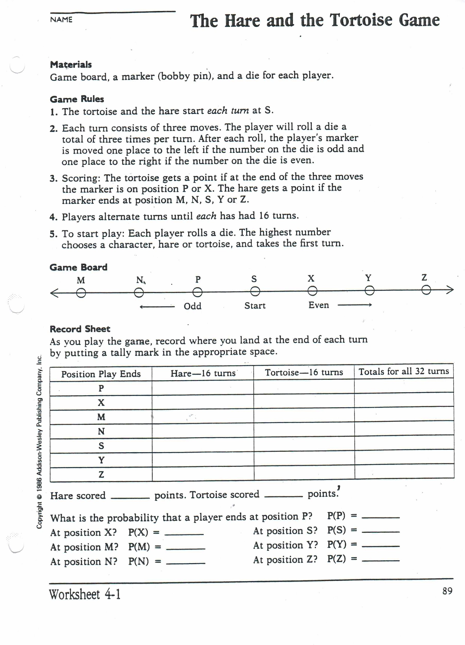

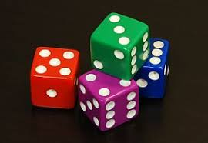
Lesson 8
Dice Game
Standard:
3.4.1.1 Collect, display and interpret data using frequency tables, bar graphs, picture graphs and number line plots having a variety of scales. Use appropriate titles, labels and units.
4.4.1.1 Use tables, bar graphs, timelines and Venn diagrams to display data sets. The data may include fractions or decimals. Understand that spreadsheet tables and graphs can be used to display data.
6.4.1.1
Determine the sample space (set of possible outcomes) for given experiment and determine which members of the sample space are related to certain events. Sample space may be determined by the use of tree diagrams, tables or pictorial representations.

Learning Targets:
1. I can find all the possible outcomes of rolling two dice.
2. I can tell you the difference between the likelihood of rolling Snake Eyes versus the Lucky Number Seven!
3. I can chart the results of my experiment and identify patterns.

Materials:
Pairs of dice (two different colors, i.e. red & blue)

Launch: Ask students if they’d like to learn how to answer some of those tough
probability questions, such as, “How likely is it that the total of two rolled dice will be six?” or "What is the probability of rolling two threes?"

Explore:
- Explain to students that they can learn a great deal about probability using just 2 dice.
- Ask students how many different possible outcomes there are if they were to roll 2 dice. Remind them that there are 6 options on each dice. Together, you can determine that there are 36 possible rolls.
- Ask how many ways there are to roll a total of “2” using two dice. They should conclude that there is only one way: 1 + 1.
- Ask students how many ways there can think of to roll a total of “7.” They should come up with 6 combinations: 1 + 6, 6 + 1, 2 + 5, 5 + 2, 3 + 4, 4 + 3.
- Time to figure out all of the rolls. Have students figure out the last two columns of the following chart. They’ve already figured out “2” & “7.” Now they can figure out the remaining numbers in the same fashion.

Total to Roll | Ways to Get the Total | Probability of that Roll
2 |  | 1/36
3 |  | /36
4 |  | /36
5 |  | /36
6 |  | /36
7 | 6 | 6/36 = 1/6
8 |  | /36
9 |  | /36
10 |  | /36
11 |  | /36
12 |  | /36

When finished, the chart should look like this:
Total to Roll | Ways to Get the Total | Probability of that Roll
2 | 1 | 1/36
3 | 2 | 2/36 = 1/18
4 | 3 | 3 /36 = 1/12
5 | 4 | 4/36 = 1/9
6 | 5 | 5/36
7 | 6 | 6/36 = 1/6
8 | 5 | 5/36
9 | 4 | 4/36 =1/9
10 | 3 | 3/36 = 1/12
11 | 2 | 2/36 = 1/18
12 | 1 | 1/36

Share: When all groups have finished, report your results to the class. As a class, total the groups’ tallies for each outcome and record these totals
Summarize: Which outcomes occurred most frequently? Which outcomes occurred least frequently? What conclusion can you draw from the results? What are all the possible outcomes for each combination and does that have a bearing on the outcomes? What outcome can you delete from your table? Ask students to turn to someone near them and tell them why it is slightly more likely to roll a sum of 7 than a sum of 6 on two dice.

Lesson 9
Card Game
Standard:
3.4.1.1 Collect, display and interpret data using frequency tables, bar graphs, picture graphs and number line plots having a variety of scales. Use appropriate titles, labels and units.
Learning Targets:
I can collect data.
I can better predict the likelihood of an event happening.
Materials:
Deck of playing cards for each player
Scratch paper (1 sheet per player)
Pencil for each player
Launch: Ask students what their favorite card game is and why they like it. Talk about how some games are fair and some are not. Explain that today we will discover what makes a game fair or not.
Explore:
1. Have student take out the ace through 6 cards of each suit in their deck of cards and set the rest of the cards to the side. (There will be 24 cards total used to play this game.)
2. Ask student this question: With 24 cards and 4 aces, what is the probability of an ace being drawn? Since 1/16 of the cards are aces, the chances are 1 in 6.
3. Student should spread the 24 cards out, face down, on the table.
4. Each player picks up 6 cards and writes down how many aces were drawn.
5. Shuffle the cards and spread them out to choose 6 cards again.
6. Whoever has the highest score after round 10 wins!
*Variation: Try adding more cards and see how it changes the probability.
Share: Ask players to discuss their results. Did anyone beat the odds? Who selected more than one ace?
Summarize: Ask students to explain why they think this game is fair. Help them to understand that it is fair because each student has the same amount of cards that include 4 aces.

Lesson 10
Flipping Coins
Standard:
3.4.1.1 Collect, display and interpret data using frequency tables, bar graphs, picture graphs and number line plots having a variety of scales. Use appropriate titles, labels and units.
4.4.1.1 Use tables, bar graphs, timelines and Venn diagrams to display data sets. The data may include fractions or decimals. Understand that spreadsheet tables and graphs can be used to display data.
Learning Targets:
I can collect, display, and interpret data.
I can use appropriate titles, labels, and units.
I can use tables and graphs to display data sets.
Materials:
Flipping Coins Lab Sheets
Pennies
Pencils
Launch:
Tell the students, “You want to play video games every day for the month of June since school just got out. Your mom doesn’t want you to play video games every day. You decide to made a deal with your mom and flip a penny every day of the month. Which do you think would give you the best chances of playing video games every day: calling heads or tails?”
Explore:
Each student should get one penny to flip, recording the first flip as the first day of the month, and marking the proper box in the calendar with “H” for Heads, or “T” for Tails. For every day that students mark “H,” mark the number of heads that have shown up so far in the table. Students will then need to compute the percent of times heads has shown up for every day of the month. When completed with the 30 trials, have students use the percent of heads per day to graph the probability of getting heads.
Share:
Every student should tape their graph up on the board, separated into two categories: starting at 100%, and starting at 0%. This will allow students to compare the graphs visually. The teacher can lead a discussion on what students think would be the best method for them to win, and play video games every day in June.
Summarize:
Ask students if there is a reason why they chose what they did. Have an open discussion about what they thought should have happened with a coin. Should it have been fair or not? Was it fair?

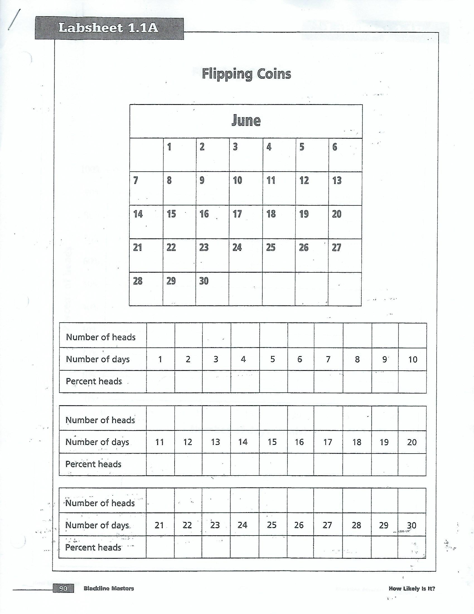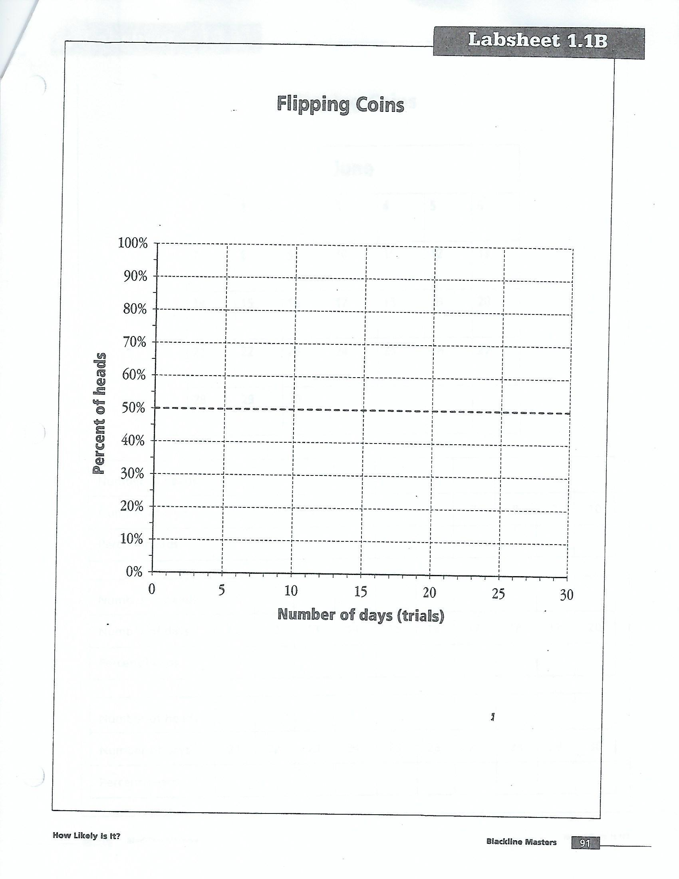

Lesson 11
Pirate’s Treasure (The Maze)
Standard:
3.4.1.1 Collect, display and interpret data using frequency tables, bar graphs, picture graphs and number line plots having a variety of scales. Use appropriate titles, labels and units.
4.4.1.1 Use tables, bar graphs, timelines and Venn diagrams to display data sets. The data may include fractions or decimals. Understand that spreadsheet tables and graphs can be used to display data.
Learning Targets:.
I can interpret data using picture graphs.
I can use appropriate labels.
I can use tables to display data sets.
Materials:
Pencil
The Maze Worksheet
Another Maze Worksheet
Launch: How many of us have seen the new Pirates of the Caribbean movie? Jack Sparrow wants to hide some of his treasure. He has two caves to choose from, but each one has multiple entrances. Which cave would his treasure be the safest in?
Guide students on how to find the probability, using the chart provided, of finding the treasure in either cave.
Explore:
Have students work in small groups, or pairs, to figure out the probability of finding a treasure hidden in either cave of “Another Maze.”
Share:
Students will share their ideas on the board, as a group. Do not have them put their answers on the board until all students have come up with an answer.
Summarize:
Discuss the different methods, and ask students what they found (be sure to use the word probability).

Extension:
Use the hats probability page to solidify the ideas learned in this lesson.
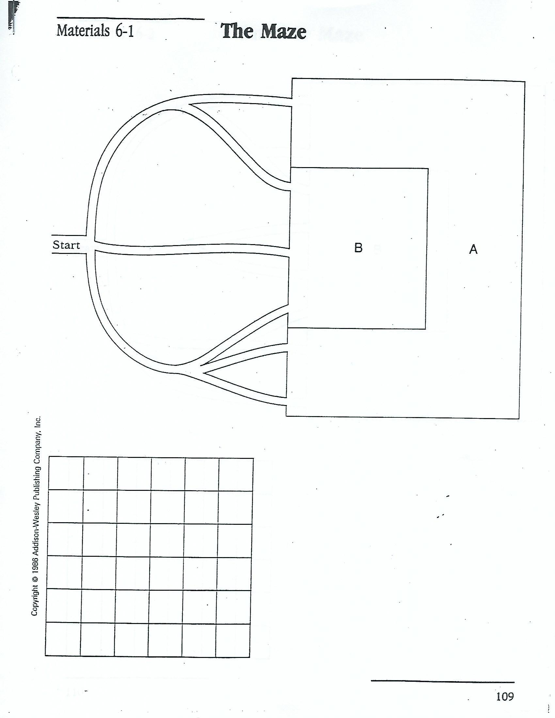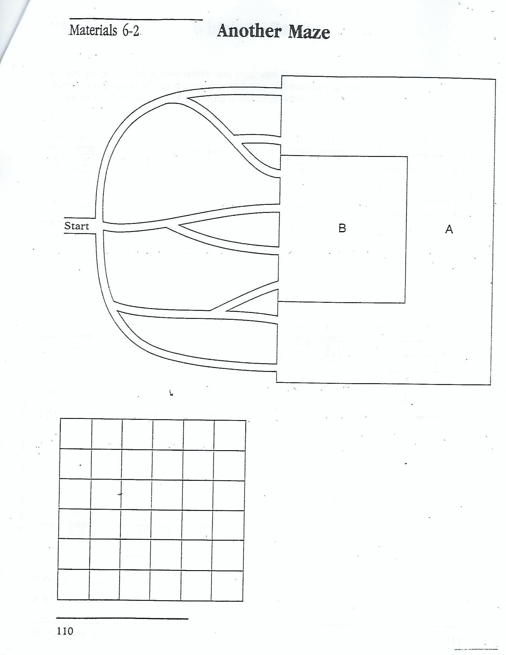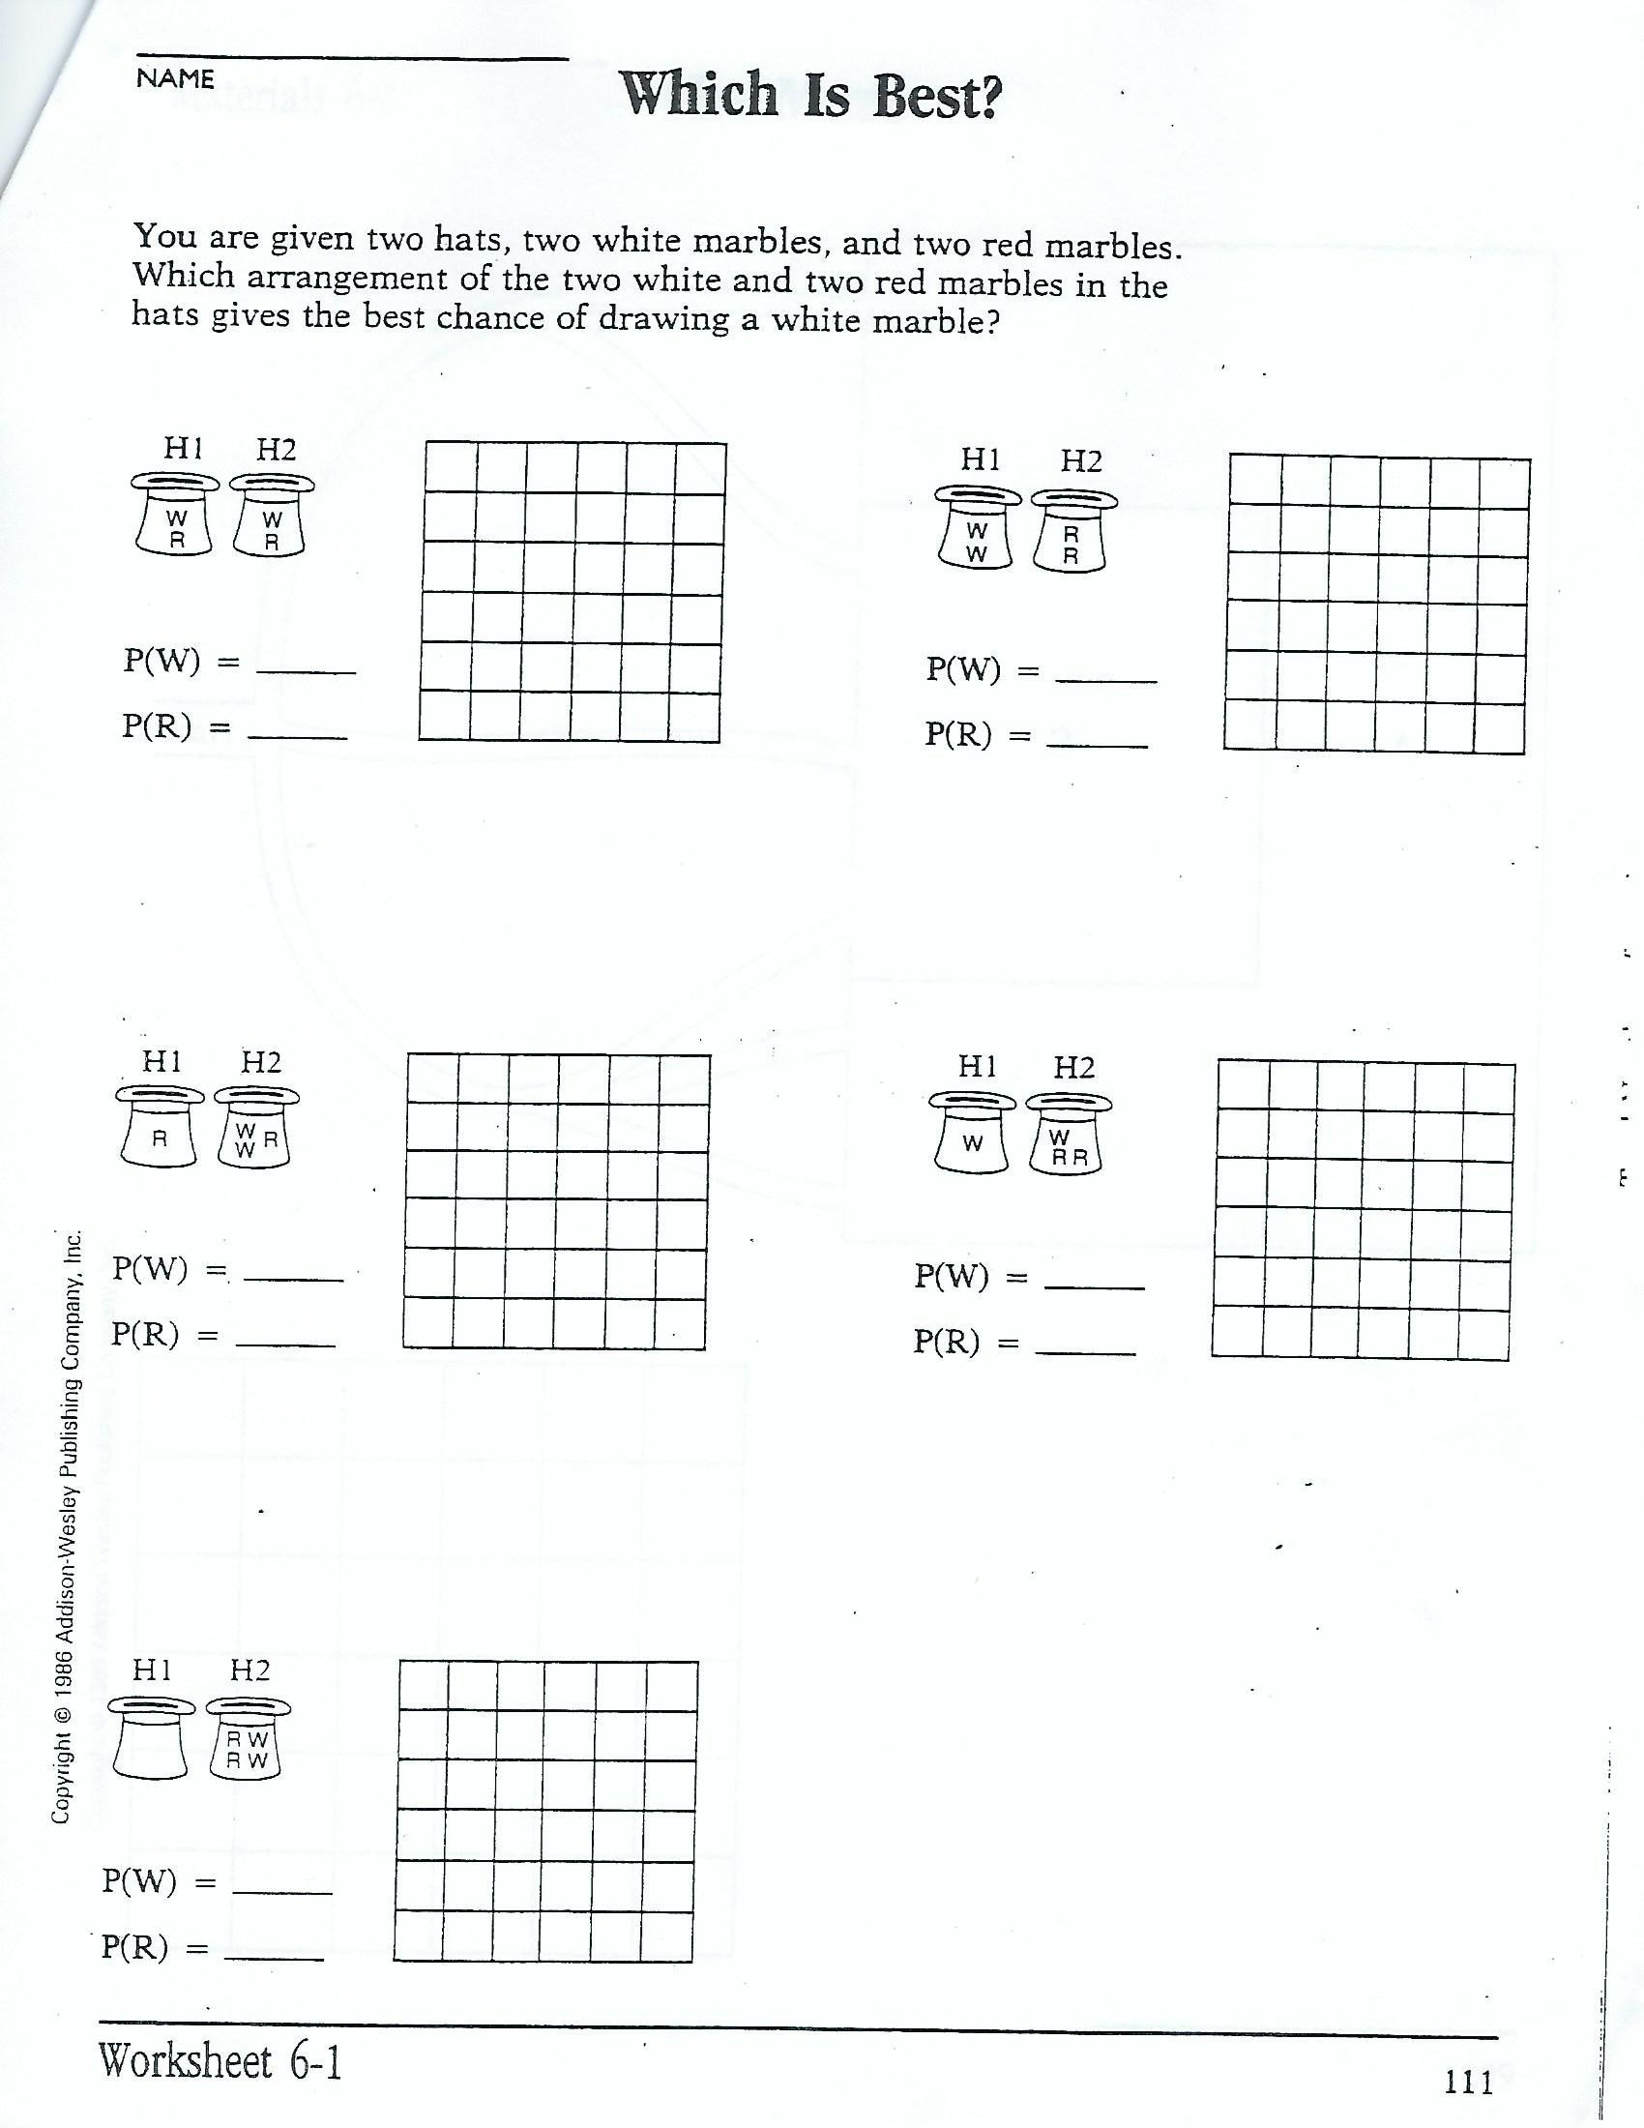

Lesson 12
The World at Your Fingertips
Standard:
3.4.1.1 Collect, display and interpret data using frequency tables, bar graphs, picture graphs and number line plots having a variety of scales. Use appropriate titles, labels and units.
4.4.1.1 Use tables, bar graphs, timelines and Venn diagrams to display data sets. The data may include fractions or decimals. Understand that spreadsheet tables and graphs can be used to display data.
Learning Targets:.
I can collect, display, interpret data using frequency tables.
I can use appropriate titles, labels, units.
I can use tables and bar graphs to display data sets.
Materials:
Inflatable Globes
Blackline Master 18, The Earth’s Surface
Blackline Master 19, World at Your Fingertips
Blackline Master 20, Does It Hit Land or Water?
Ready Reference 6, Simulation: A Probability Experiment
Pencil
Dot Stickers or something to draw a dot on a finger with
Launch:
Display the first page, “Where Will the Meteorite Land?” and ask students the following questions to facilitate discussion:
- Do you think the meteorite is more likely to hit the land or water? Explain.
- What previous knowledge do you have about the surface of the Earth that will help you to make a prediction?
- If the meteorite hits land, it is likely to hit North America? How can we use simulation to investigate this question?
Explore:
We can’t wait for a series of meteorites to hit the Earth, but we can model the event happening. This technique of creating an experiment that will model a real world experiment is called simulation. Simulations allow us to study properties of real-world events that are too complicated, too expensive, or impossible to actually observe.
Discuss ways to simulate events.
Conduct the following simulation as a class activity.
Place a red dot on the tip of each student’s right index finger with an overhead marker. This will represent the meteorite. Students will toss an inflatable globe to each other with a spin. Each person will catch the globe with two hands. He or she will tell where the meteorite (the red dot on his or her finger) landed. Have the class make a prediction about the outcome of the experiment and record that prediction on the tally sheet. Toss the globe 100 times. Each outcome is reported to the recorder who will tally the results and will inform the class when 100 tosses are complete. Two globes will save time, or you can split students into small groups and use multiple globes.
Students should be able to state which continent or body of water was the landing spot. A geography review may be necessary to help students identify continents and oceans. All data should be recorded on World at Your Fingertips. Select a person to record the data and to signal the next toss. Select another person to tally the total number of tosses and to alert the group when 100 tosses are complete.
Share:
Once students have returned to their seats, the recorder can report the total tally for each continent and ocean. Each student should record the count, then express it as a relative frequency (the number of times the event occurred divided by the total number of tosses) and as a percent. The actual percentages can later be displayed on the overhead for students to copy and compare.
The experimental values may not be the same as those listed on The Earth’s Surface. Remind students that this is a simulation and although totals may not be exact, they should be close if we perform enough trials. Consider challenging students who are able to research the actual percentage using an atlas or almanac rather than your supplying it for the students.
These questions can help students analyze their findings as they begin to formulate a solution:
- What is the probability of the meteorite hitting the water? How did you obtain your results?
- What is the probability of the meteorite hitting the land? How did you obtain your results?
- Were the results what you expected? Explain.
Have students determine the probability of the meteorite hitting North America or one of the other six continents. Discuss the chance of this event occurring.
Display the transparency so that students can examine data on The Earth’s Surface. Then they can compare their experimental results with the predicted results.
Discuss the fact that these two events cannot overlap. If a meteorite hits Earth, it will either hit land or water. These events are said to be mutually exclusive. The sum of the probabilities of mutually exclusive favorable events is equal to 1.
P(hitting land) + P(hitting water) = 1
Another example of a mutually exclusive event is the tossing of a coin. It will land heads or tails. The sum of both probabilities equals 1.
Summarize:
Have students write a report indicating what they believe will happen when the meteorite hits the Earth. Have them include the results of the class simulation as well as the results obtained from the data given about surface area. Students should also include the similarities or differences in the results and provide an explanation for their conclusions. Could this simulation have been executed in a more accurate manner, and if so, how?

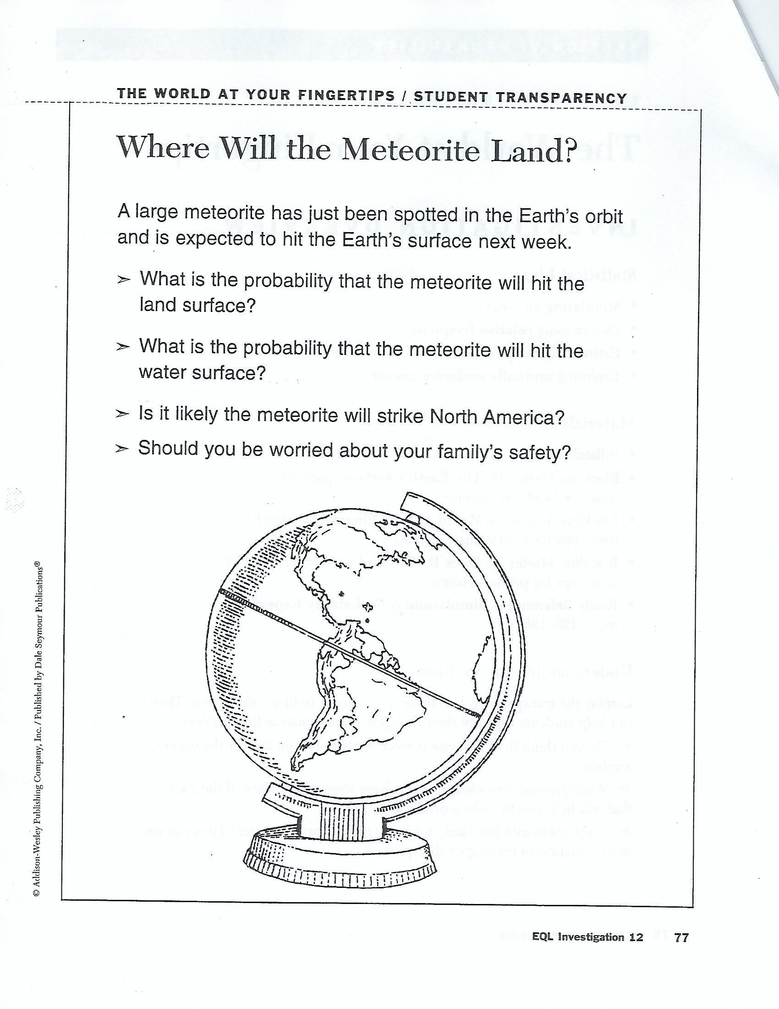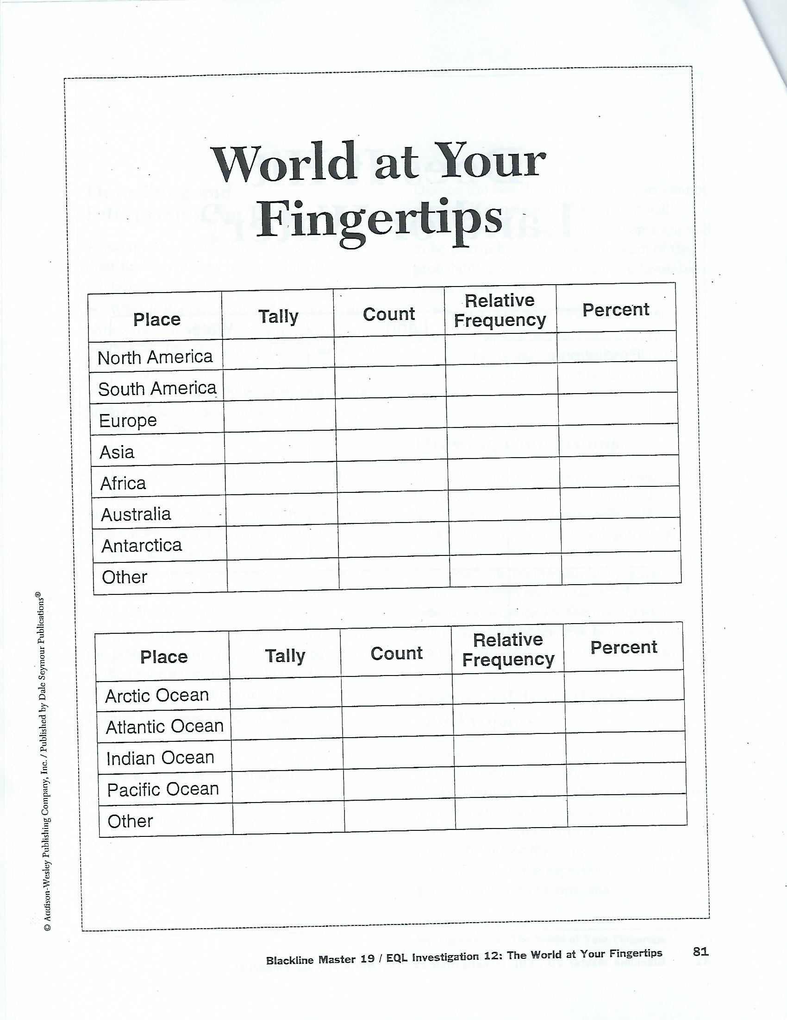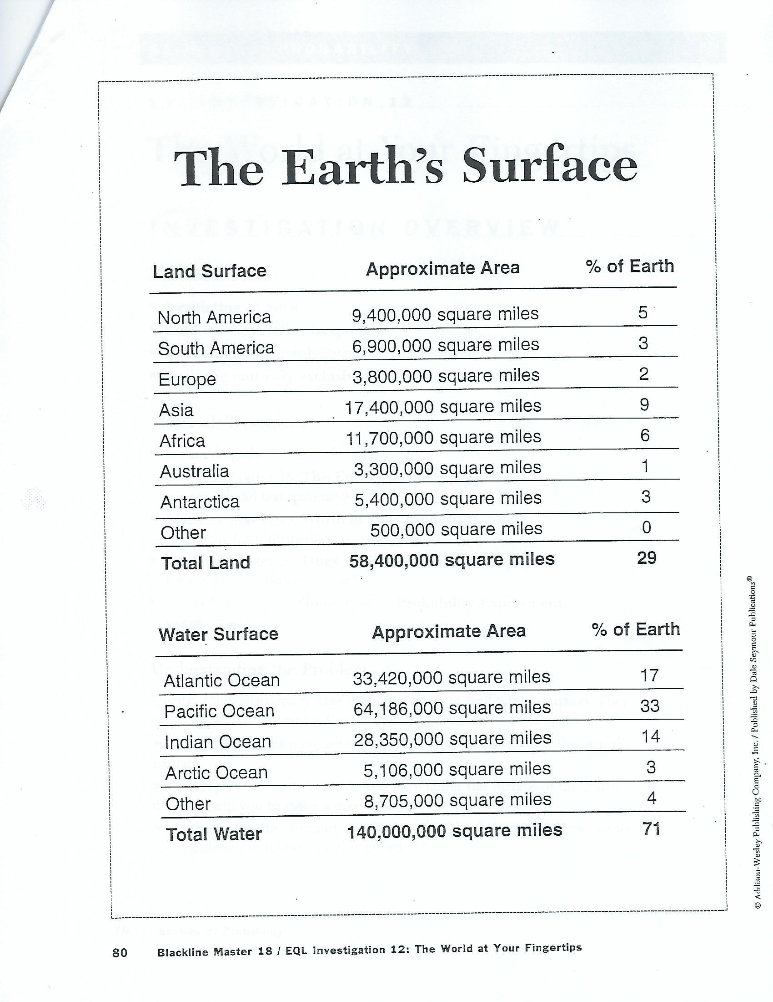

Lesson 13
Mystery Spinners (The Big Wheel)
Standard:
3.4.1.1 Collect, display and interpret data using frequency tables, bar graphs, picture graphs and number line plots having a variety of scales. Use appropriate titles, labels and units.
4.4.1.1 Use tables, bar graphs, timelines and Venn diagrams to display data sets. The data may include fractions or decimals. Understand that spreadsheet tables and graphs can be used to display data.
Learning Targets:
I can collect, display, and interpret data using bar graphs.
I can use bar graphs to display data sets.
Materials:
Large sheets of poster paper
Markers or crayons
Blackline Master 21, The Big Wheel, page 58 (one for each student)
Ready Reference 5, Probability, page 124
Launch:
Display the transparency. Use these questions to facilitate discussion. They can help students organize their thoughts as they analyze the problem.
- What are all the possible outcomes on the spinner?
- How many times in total did they spin the spinner last year?
- Did one or more of the colors have a higher frequency than the others?
- Would this affect the way you would reconstruct the spinner?
- How does the fact that Iva Memory remembers that there were 10 equal parts help in making a new spinner?
Explore:
Divide students into groups. Give each student a copy of The Big Wheel. Ask students to use the data from Seymour Tally to color the regions of the spinner used at last year’s carnival.
Students in each group can then share their spinners and discuss why they chose to color their spinner in a particular way.
Give each group a mystery spinner which will not be shown to anyone in the class. Mystery spinners can be made inexpensively from poster paper by following these directions:
Making a Mystery Spinner
Draw a circle on a piece of tag board or poster paper. Divide the circle into regions and color each region. Place a paper fastener through a paper clip and secure it to the middle of the circle. Adjust the paper fastener so that the paper clip spins freely.
Have each group conduct a probability experiment by spinning the spinner 25-30 times and recording the outcome of each spin in a frequency table. Before they begin the experiment, ask each group to predict what they think will happen in the experiment. Afterwards each group will make a chart or bar graph of the data.
Groups will then take turns sharing their data displays with the entire class while being careful not to show their mystery spinner. The rest of the class will describe the spinner based on their interpretation of the data. After these descriptions have been given, the groups will reveal their mystery spinners.
Share:
As you describe each group’s spinner consider the following:
- Based on the data collected, what are all the possible outcomes?
- What are the chances that there was another possible outcome on which the spinner did not land?
- What color did the spinner land on the least?
- Is there one outcome that occurs more often than others? Is there a logical explanation for this?
- If you were going to spin the spinner, on what color do you think that it would most likely land?
- How could you improve your chances of making the correct prediction?
Summarize:
Have students write a brief paragraph describing one of the group’s mystery spinners. They should include all the possible outcomes as well as statistical evidence to support their statements. Students could make a drawing of the other groups’ spinners.
Extension:
Students may want to design their own mystery spinners and ask other students to guess their design.

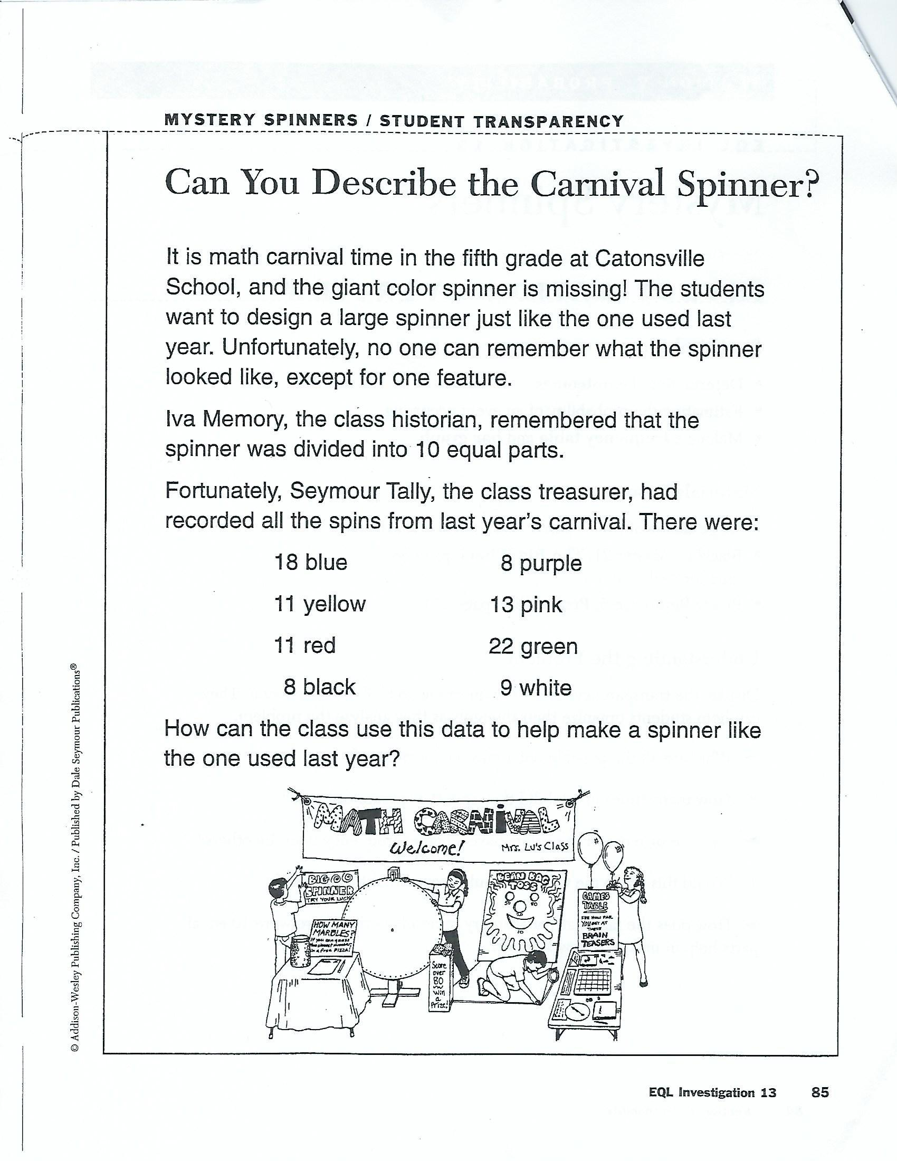
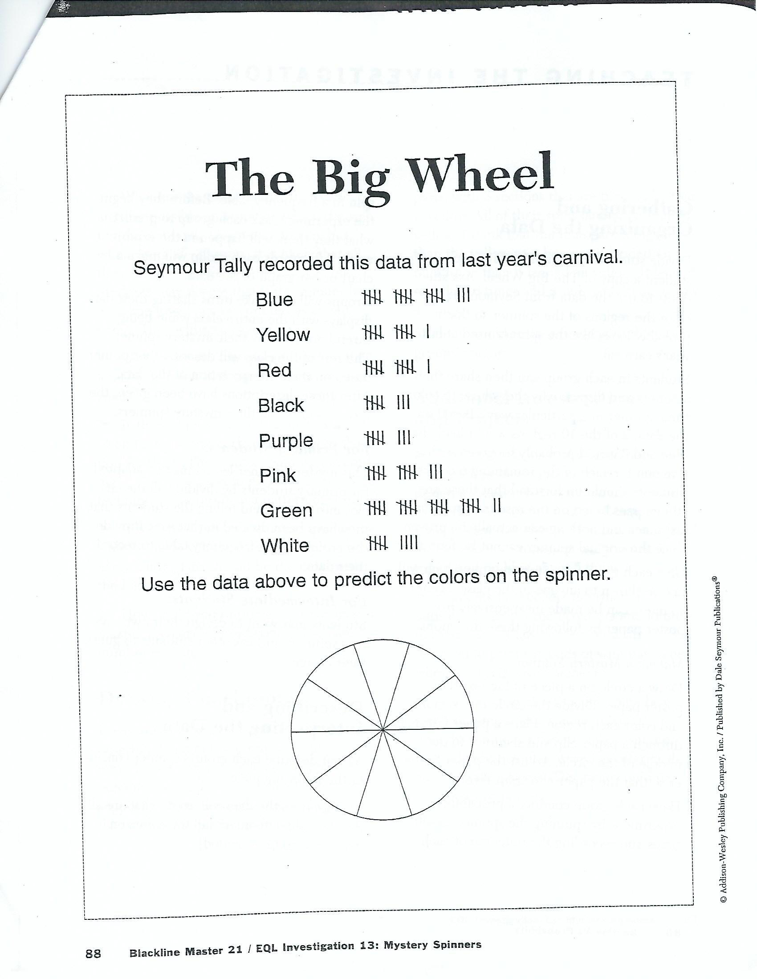

Lesson 14
Scoring Option Game
from Investigations
Standard:
3.4.1.1 Collect, display and interpret data using frequency tables, bar graphs, picture graphs and number line plots having a variety of scales. Use appropriate titles, labels and units.
6.4.1.1 Determine the sample space (set of possible outcomes) for given experiment and determine which members of the sample space are related to certain events. Sample space may be determined by the use of tree diagrams, tables or pictorial representations
Learning Targets:
I understand the meaning of factors, multiples, odd, even, and square numbers.
I can use probability in spinning a spinner to help choose the best option in this game.
Materials:
Scoring Option Game worksheets 6,7,8
Paperclips
Pencil
Launch:
We have been learning about multiples, factors, odd, even, square, and prime numbers. Can you use this knowledge to beat the spinner?
Explore:
Students work in pairs or small groups and discuss a strategy for choosing the best options in the first round of the game. Pass out student sheet 6 and play.
Share:
Have students share the results of the game and the reasons each group chose their letters. Discuss if they will change any of their previous strategies for scoring more points. Pass out student sheet 7 and play and discuss results.
Summarize:
Pass out student sheet 8. Have students create and exchange game options of their own. Discuss why they chose the options they did and how they did when they played their classmates game.

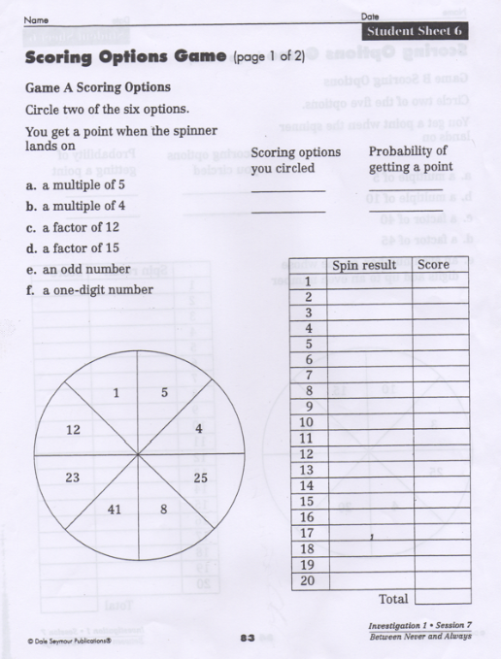
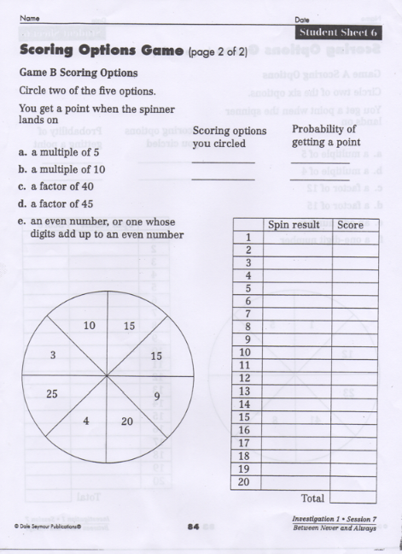

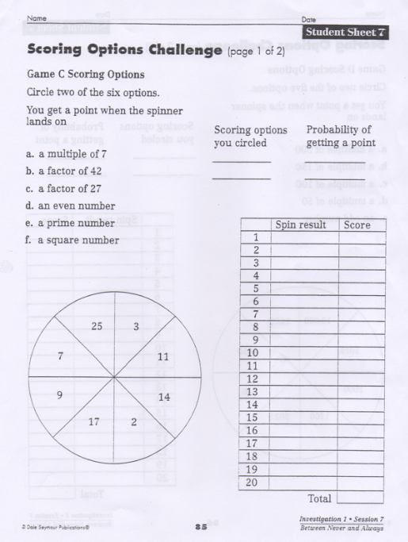

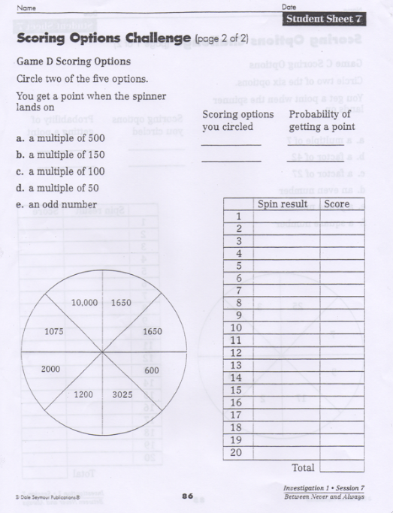
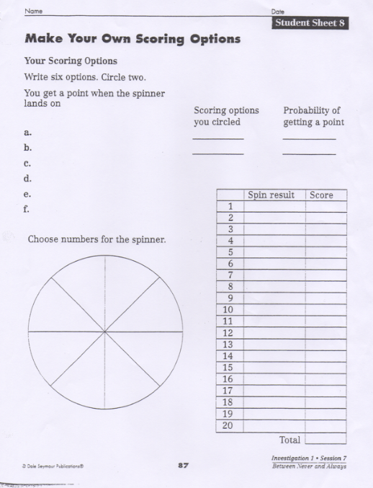
Lesson 15
Parachute Jump Competition
Standard:
3.4.1.1 Collect, display and interpret data using frequency tables, bar graphs, picture graphs and number line plots having a variety of scales. Use appropriate titles, labels and units.
4.4.1.1 Use tables, bar graphs, timelines and Venn diagrams to display data sets. The data may include fractions or decimals. Understand that spreadsheet tables and graphs can be used to display data.
Learning Targets:.
Materials:
Self-stick dots or cutouts about the size of a quarter, one per pair of students
Large index cards (optional)
Metric measuring tape or ruler, one per pair
Scissors, tape
Blackline Master 16 Making a Whirlybird, page 73
Ready Reference 5, Probability, page 152
Ready Reference 11, Histograms, pages 162-163
Launch:
Tell students, “Parachutists have competitions in which they try to land as close as they can to a target. You and your partner will simulate a parachute jump by dropping a whirlybird. Make a whirlybird and drop it to test its spin. Adjust the spin if necessary. How close do you think you can come to the target? Do you think you can come close almost every time?”
Explore:
Provide pairs of students with the pattern and directions for making a whirlybird (Blackline Master 16). Whirlybirds can also be cut from large index cards. Each pair needs only one whirlybird, but each student may want to make his/her own. The whirlybird should spin as it descends; if it doesn’t, students should adjust the angle of the wings before beginning the experiment.
Have pairs place a self-stick dot or cutout circle on the floor as a target. Before beginning the test, have student pairs create a five-column table for keeping track of the drops. Have them fill in the headings for the first three columns (see table attached below), and complete the first column with the distance ranges given. Then have the pairs follow this procedure:
Step 1) Before beginning, record a prediction for which distance range will have the most hits.
Step 2) Hold the whirlybird at shoulder height, aim it to hit the target, and let it drop.
Step 3) Using a metric tape measure or ruler, measure in centimeters the distance from the point at the end of the whirlybird to the target.
Step 4) Record the measurement in the “Tally” column of the table.
Step 5) Take turns dropping the whirlybird and measuring and recording its position until you and your partner have made a combined total of 10 drops.
Step 6) Based on the results of the first 10 drops, adjust the predictions made earlier and repeat 10 more times for a total of 20 drops.
Share:
Use these questions to guide students while analyzing their findings:
- How many drops are a direct hit (or 0cm)? How many hit within 1-10cm? 11-20cm? 21-30cm?
- We can define “on target” as on or near the target. Is 0-20cm reasonable as an on-target hit? Why or why not?
- How many drops hit within 0-20cm? Explain that the answer to this question requires adding a fourth column to the table.
Add the label “Cumulative Frequency” at the top of the fourth column. The cumulative frequency is the accumulated total number of entries across intervals, beginning with 0. Cumulative frequency is necessary in making statements that combine several intervals. This also allows students to make percentage statements about the data.
Encourage students to use their data to make statements like these:
- Eleven of the 20 drops were within the 0-30cm range.
- Nine of the 20 drops were in the 31-60cm range.
- Nearly half of the drops landed at the greater distances from the target.
In order to analyze results within one interval, relative frequency is used to make statements like this: Only 4 of 20 drops landed within 10cm, so only 20% of the drops were on target. The relative frequency makes it easy to answer questions like this: What are the chances of landing in one of the distance ranges listed? Relative frequency is the ratio of the number of times an event happens to the total number of trials. The table shows that 3 out of 20 drops hit in the 21-30cm range. So the whirlybird hit in this area 3/20 or 0.15 of the times.
Using the data in the example table, ask students to find the relative frequency of hitting each of the other ranges.
Summarize:
Have students add the label “Relative Frequency” at the top of the fifth column of their tables. Have them use calculators or mental calculation to complete ratios for each interval. The ratio can be stated as a fraction, a reduced fraction, or a decimal, and then percentage statements about the data can be made.In the example, the completed table would like the one on page 72 below.
Have student pairs complete their own tables. The results for the entire class can then be tabulated (using excel spreadsheets).Using the relative frequency from the whole-class table, ask students to name the distance range within which the whirlybird i most likely to hit, it does not tell on which particular drop such a hit will occur.
Have students find the relative frequency and compare it to their first “wild guess” prediction of which distance would have the most hits.

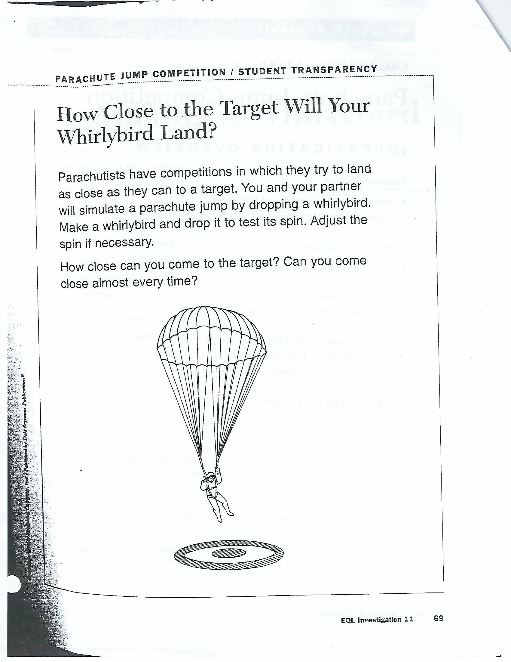
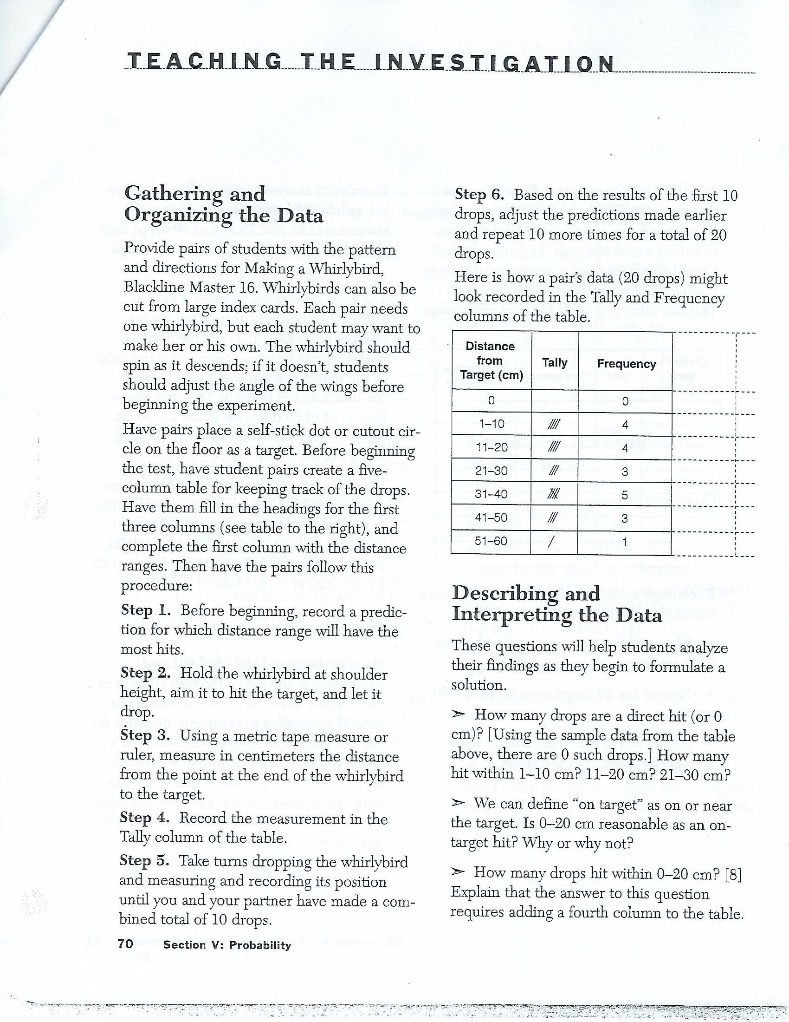
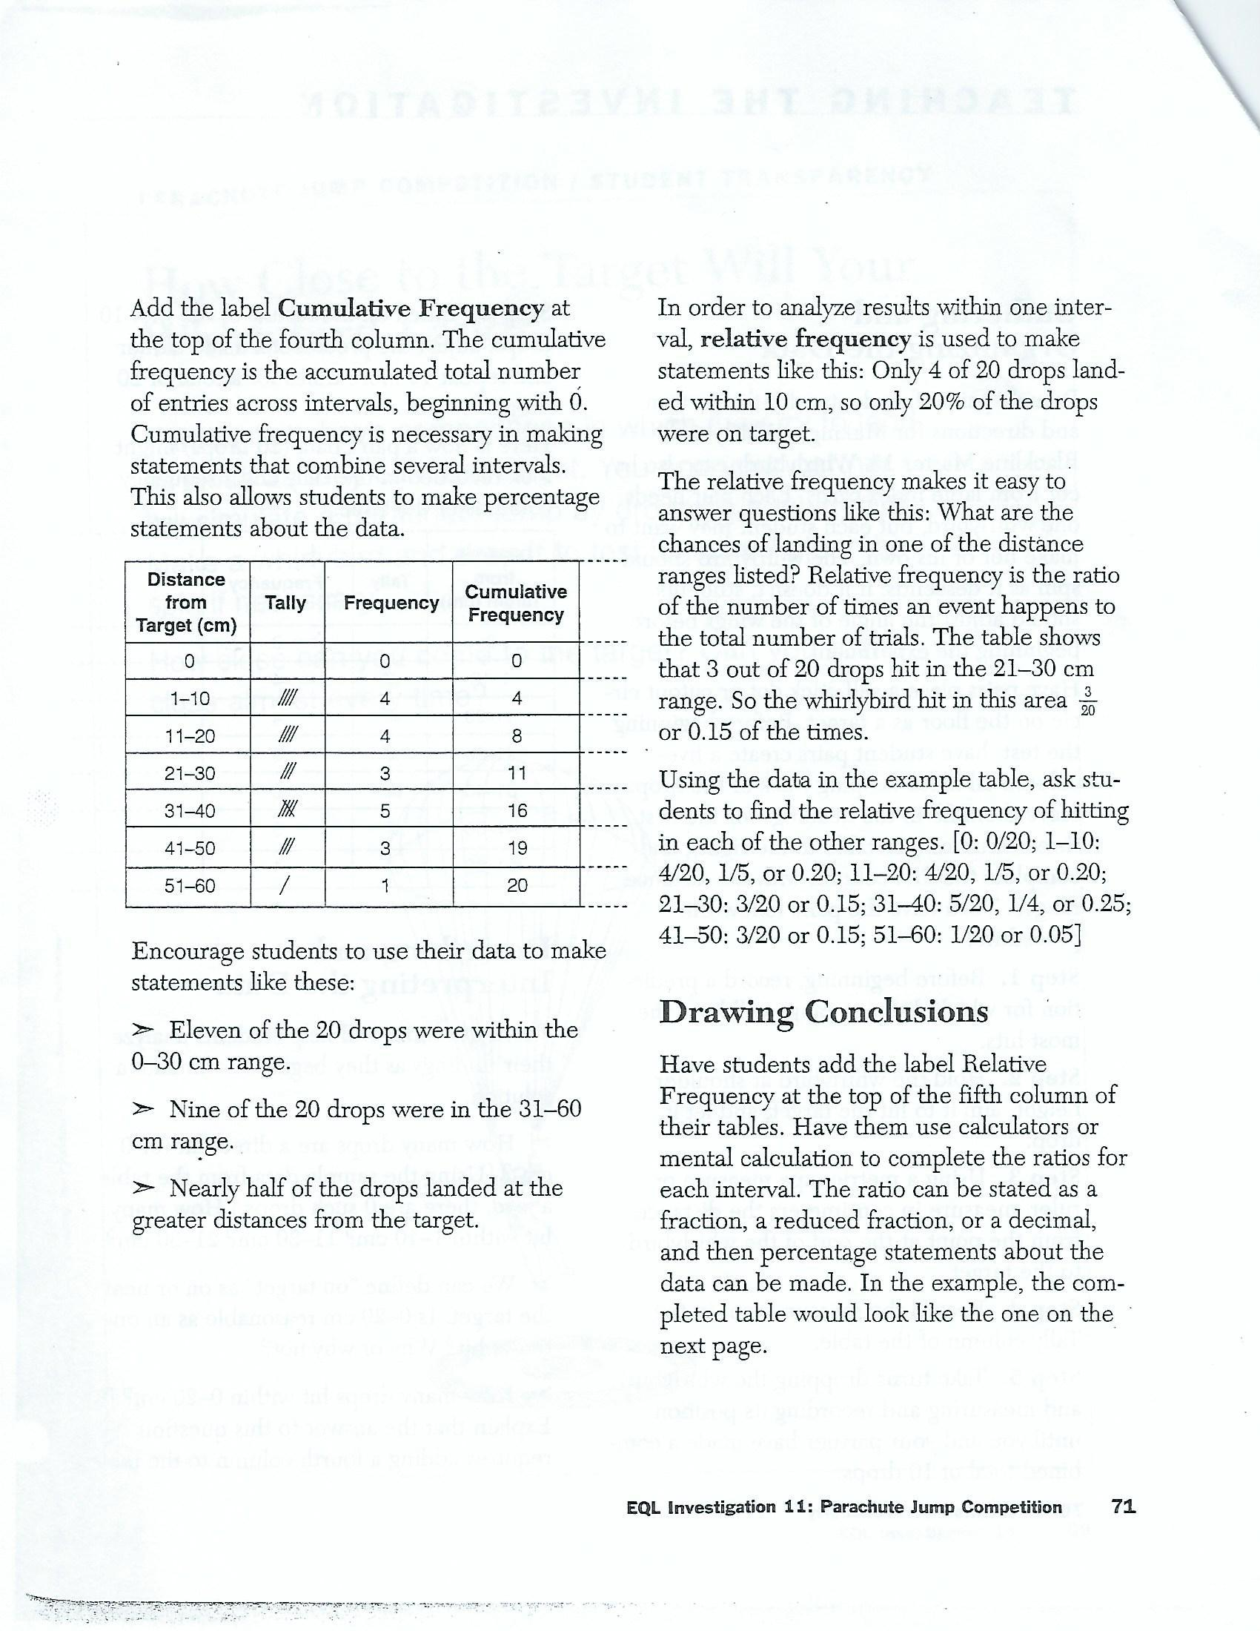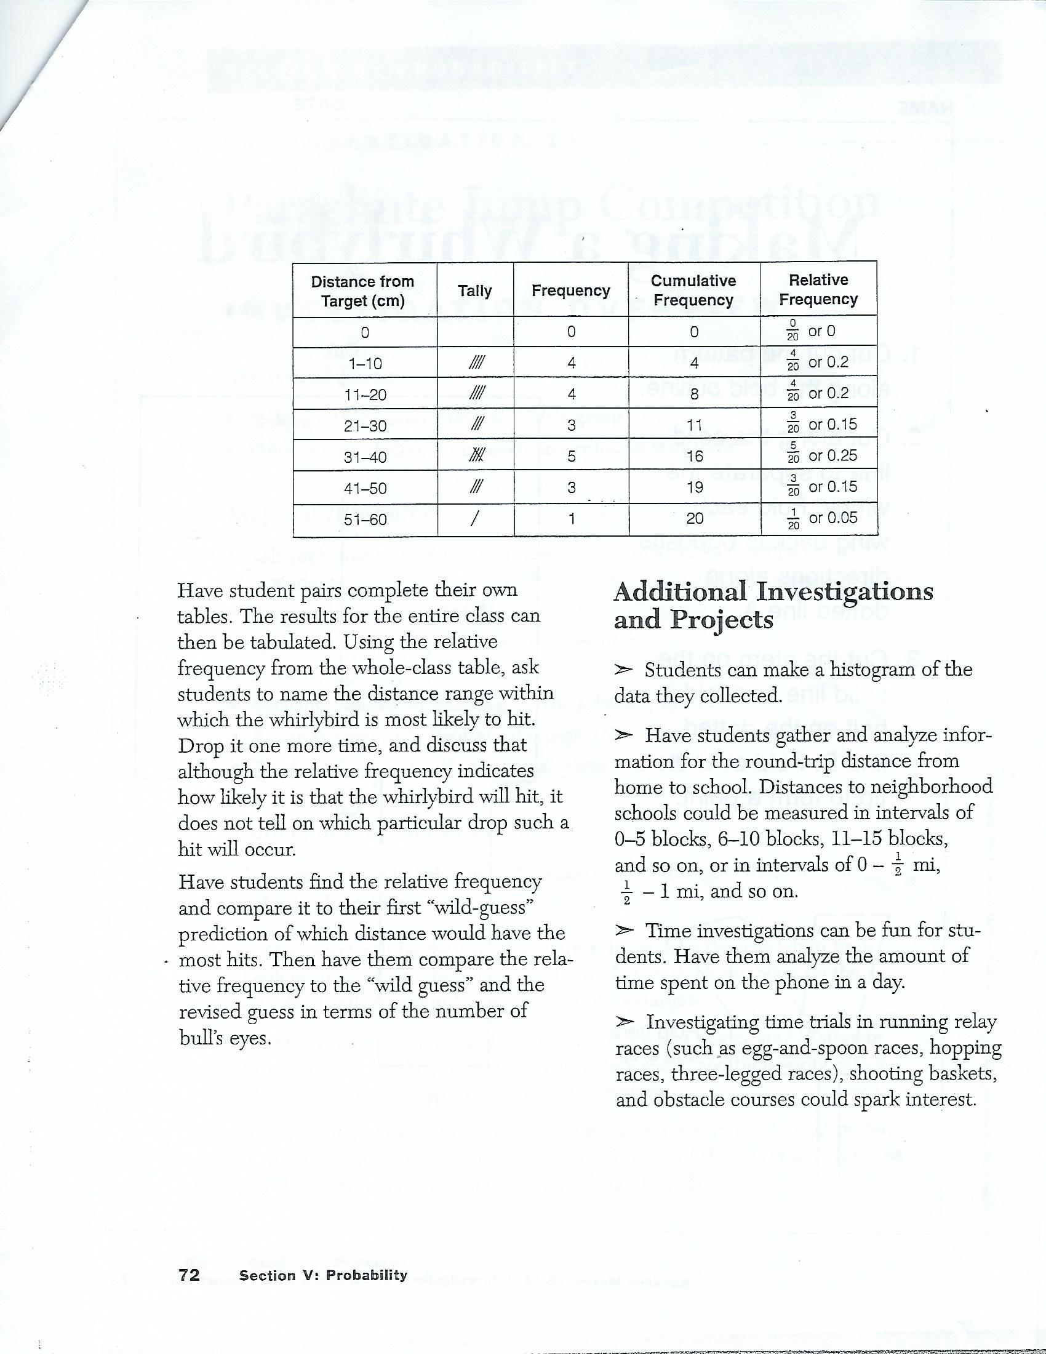
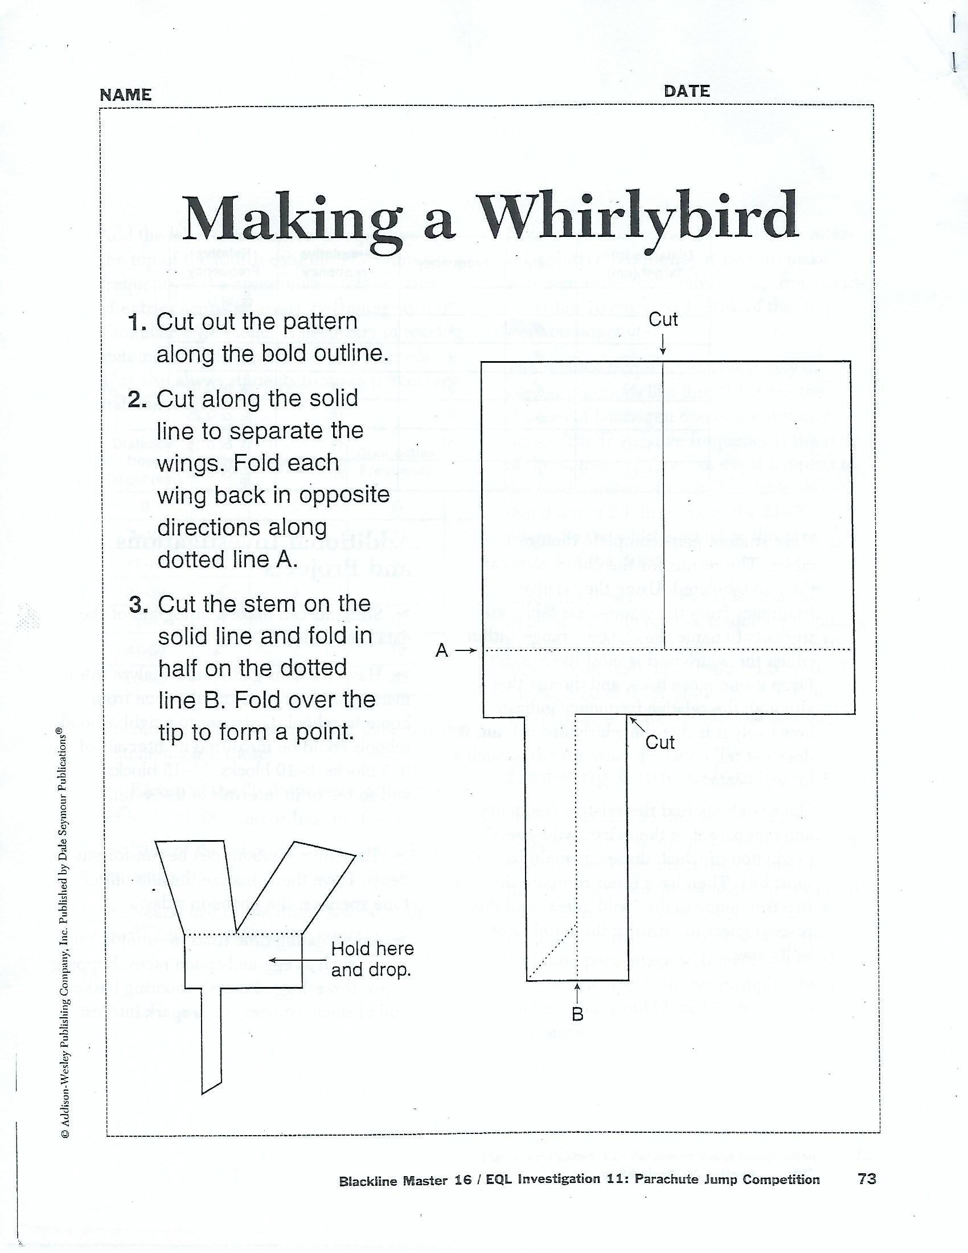

End-of-Unit Assessment

Name:_______________ Date:__________

1. On which color is the spinner more likely to land?
Yellow Orange Purple
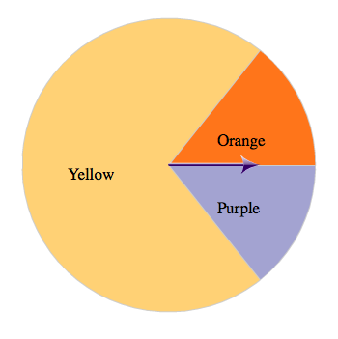
2. On which color is the spinner less likely to land?
Purple Orange
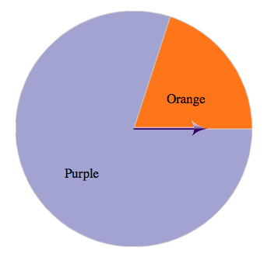

3. If you roll a 6 sided number cube, what is the probability of rolling an odd number? Write your answer as a fraction.

4. If you roll a 6 sided number cube, what is probability of rolling a two? Write your answer as a fraction.

5. If you select a marble without looking, how likely is it that you will pick yellow one?
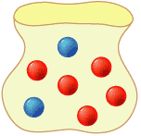

certain probable unlikely impossible

6. How likely is it that the spinner will land on an orange space?

certain probable unlikely impossible

7. The weather forecast stated that the chance of rain is 80%. According to the forecast, is it more likely to rain or not rain?

8. If a number cube is rolled once what is the probability of rolling a 1?

